1. 
2. Whenever we want to deploy something as website, we require html, css, js but for now, we have only our OpenAPI Specification YAML file.   
   Let us see how to overcome this issue.
3. **Open this link**:   
   <https://github.com/eazybytes/openapi/tree/main>
4. 
5. 
6. 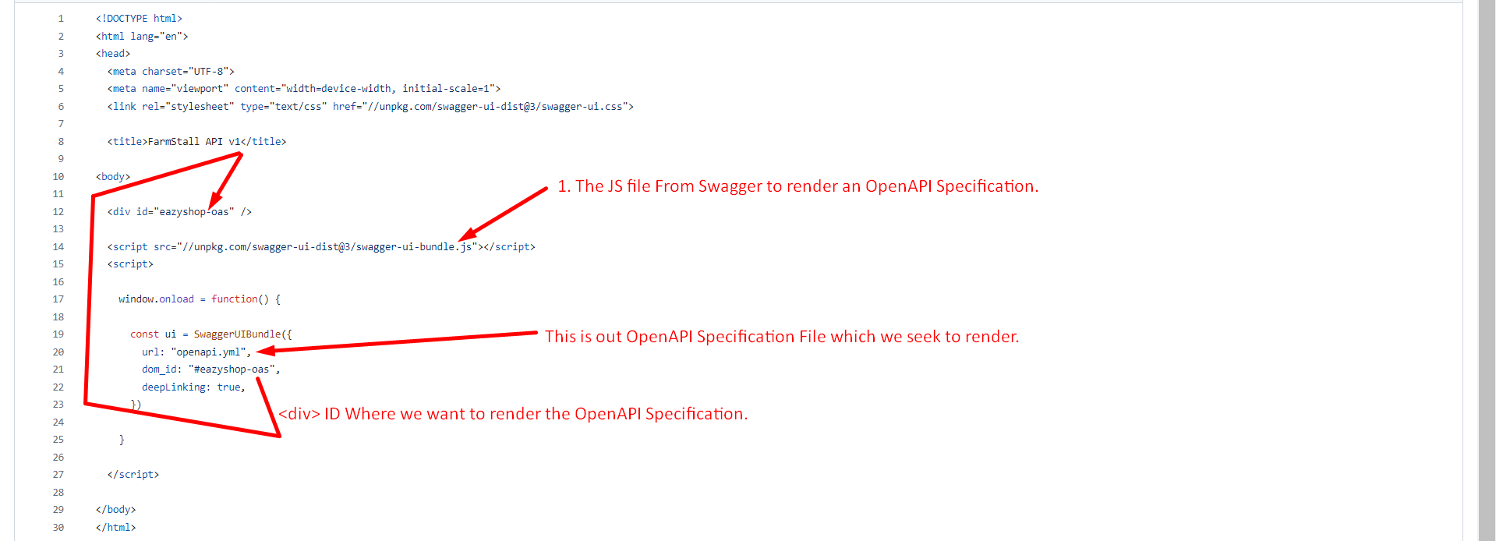
7. 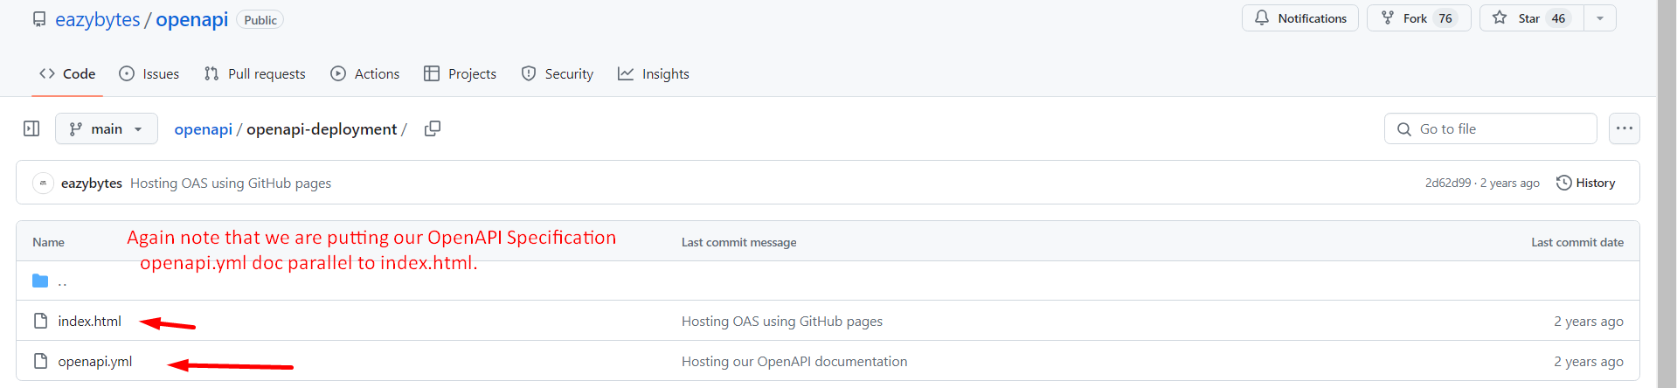
8. 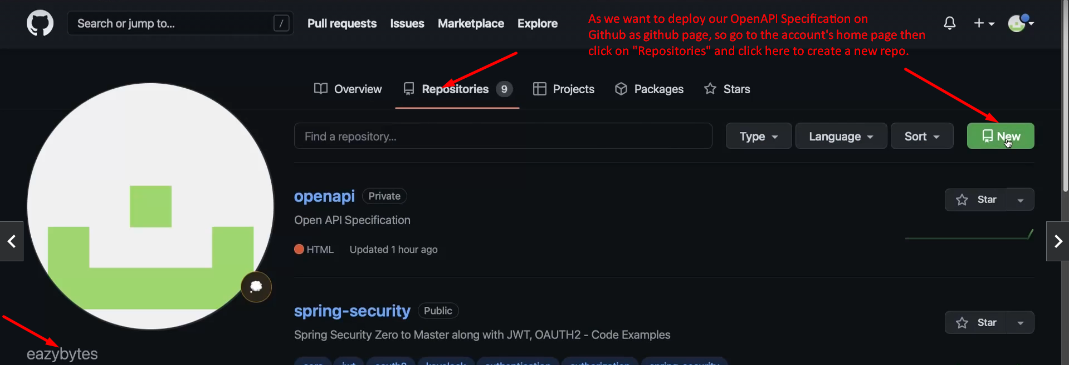
9. 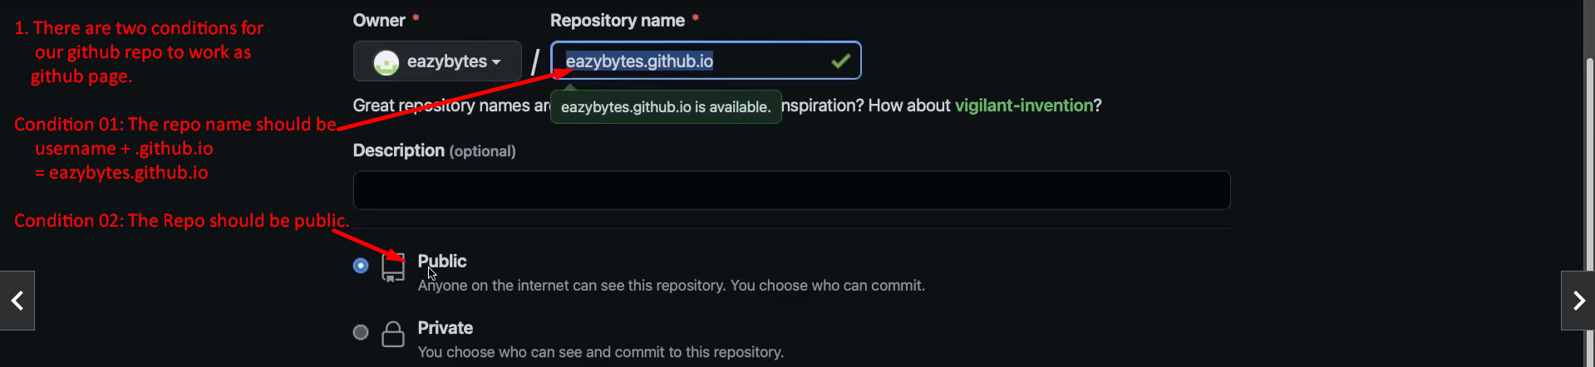
10. 
11. Initially, the repo will be empty.   
    Just add those two files
    1. index.html
    2. openapi.yml.
12. 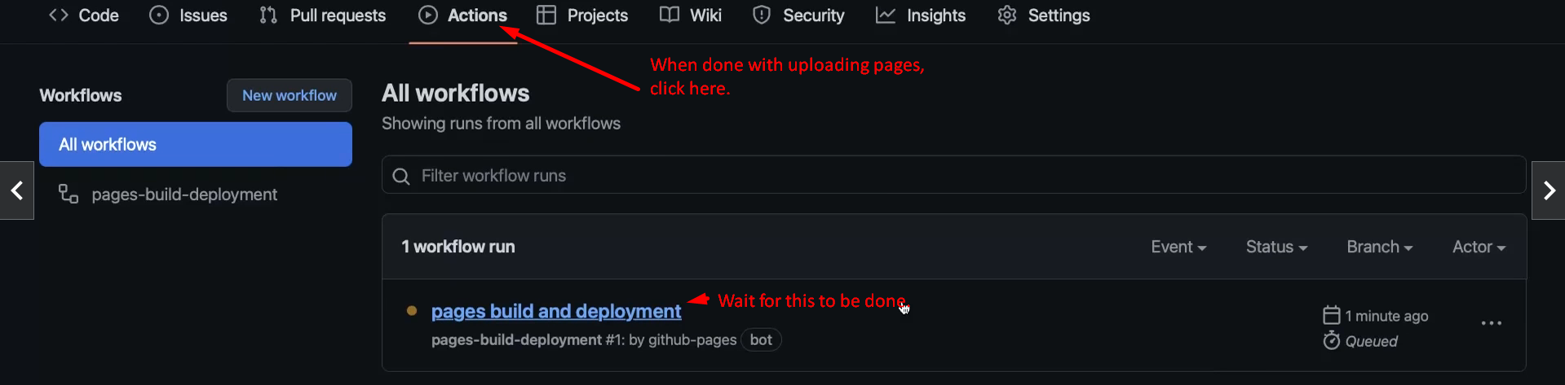
13. 